**INDIA’S AGRICULTURAL CROP PRODUCTION ANALYSIS (1997-2021)**

1. **INTRODUCTION**

India is the second largest country in the agriculture field (around 159.7 million hectare) after United States in the world. Agriculture is the most important factor for survival of life on earth. Food is the basic need for humans which can be achieved through agriculture. Nowadays, the increasing demand of food for the growing population needs to be concentrated. In order to find the needs for this population it is essential to know about the crop production in different era and compare the crop production on every year basis. In this project, the data sets are available for India’s Agricultural Crop production Analysis 1997- 2021. From the dataset given it is possible to know the states producing highest crop production, types of crops from various states, supply of foods materials to other states, export to other countries and their shipping charges, comparison of different crops according to the seasonal changes and locality, the factors affecting crop production from 1997-2021, food scarcity among different localities and how far the increasing population meet out their daily needs.

**1.1 Overview**

According to the visual representations readers can gain valuable insights into crop production, seasonal variations, regional distribution and overall production trends. These visualizations enable intuitive analysis; allowing stakeholders to uncover patterns identify areas of growth or concern. The pictorial representation also provides an interactive experience for readers to explore the India’s agricultural cultivation.

**1.2 Purpose**

From the project, we have plotted a graph for the different variables given in data sets. This visualization represent data set that are too numerous or complicated to be described in the text format and pictorial representation. In this, the visualization gives the information about area, crop, production, yield, year, zero line, season, state, etc…. The data set is behaving and making full observation and prediction of the

**2. Problem definition and design thinking**

**2.1 Empathy map**

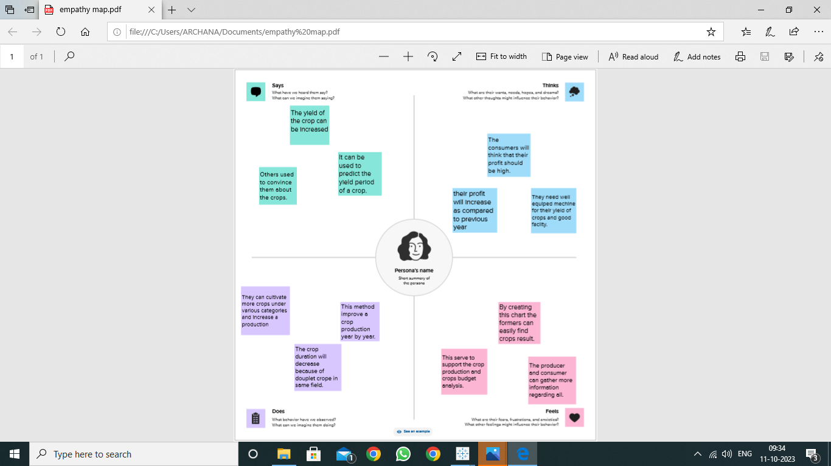

* 1. **Ideation and Brainstorming map**

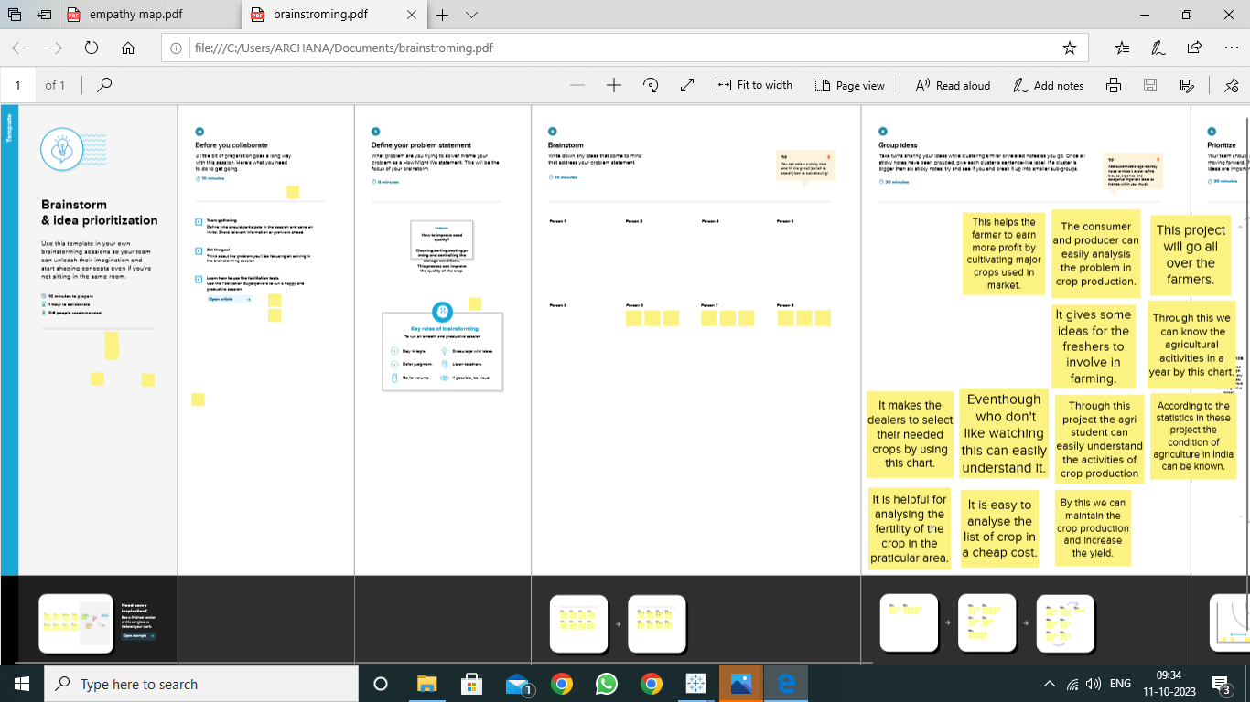

**3. Result:**

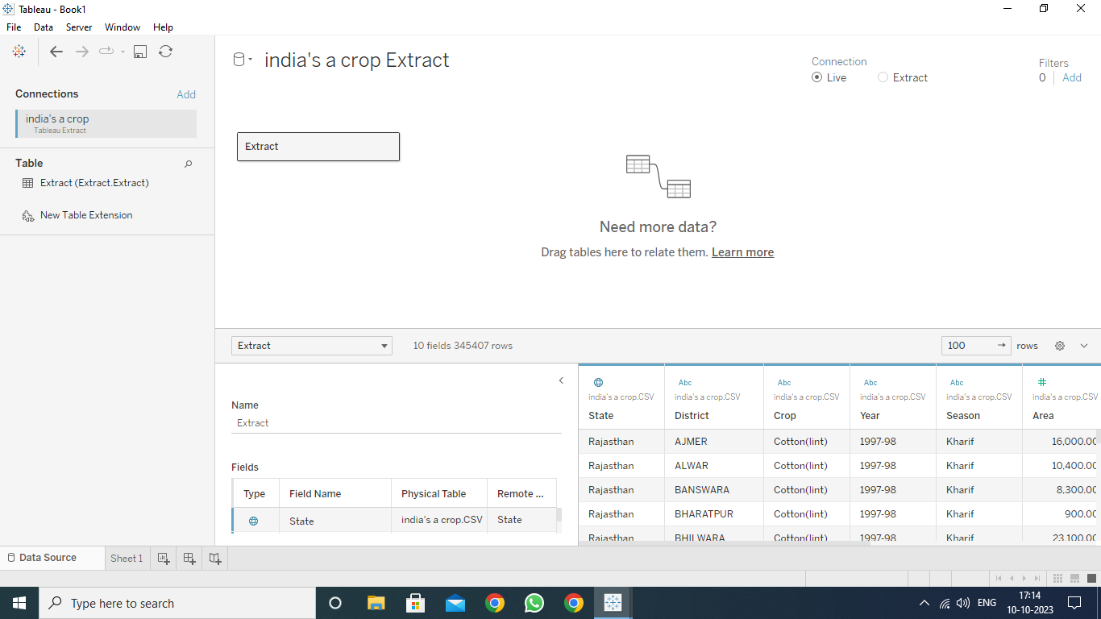

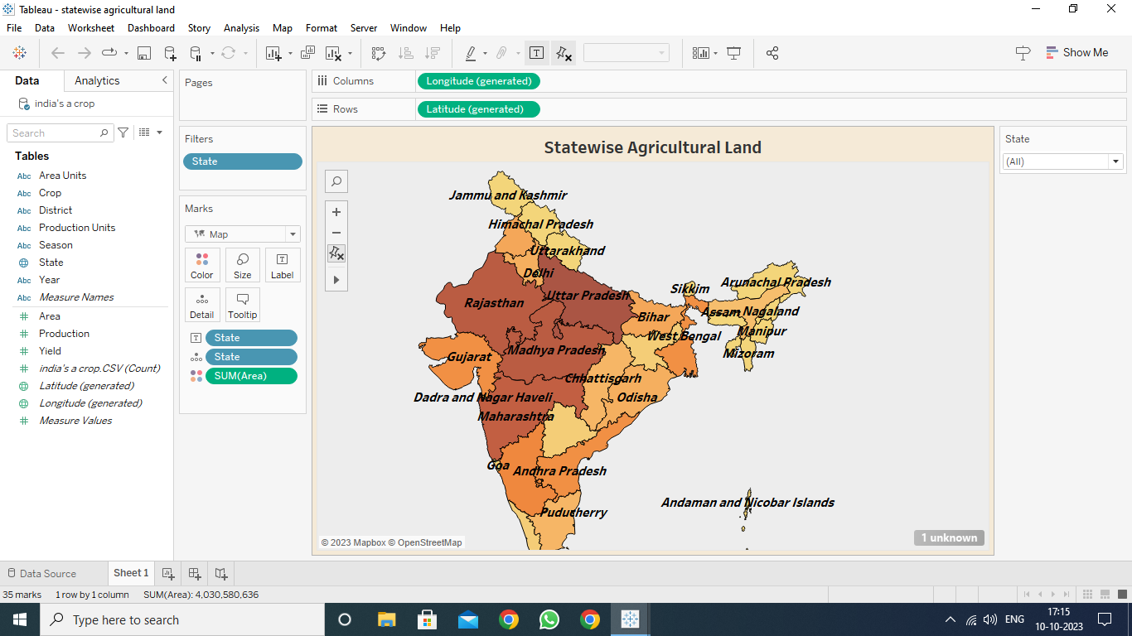

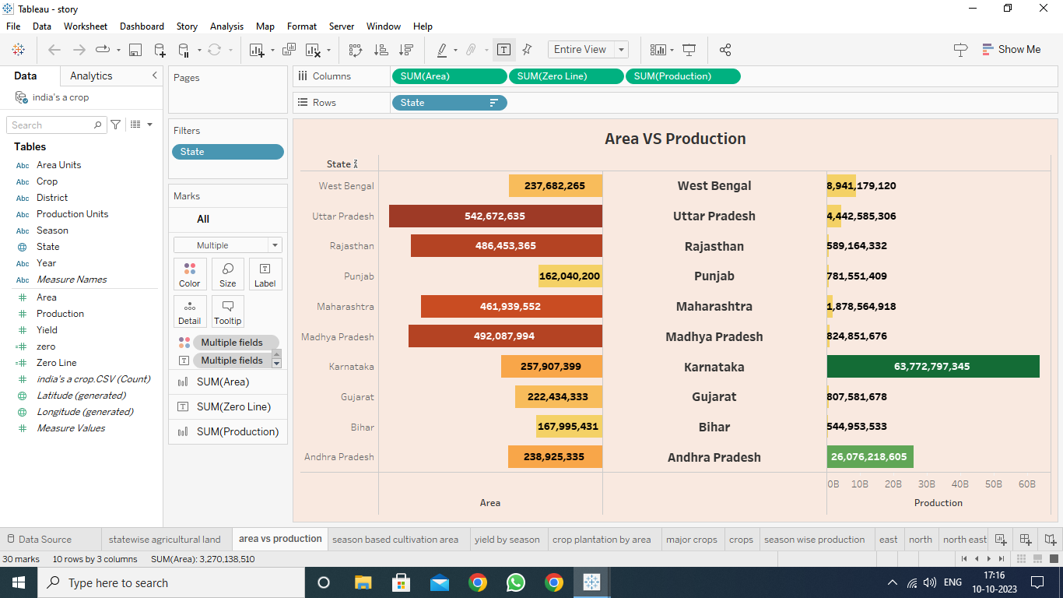

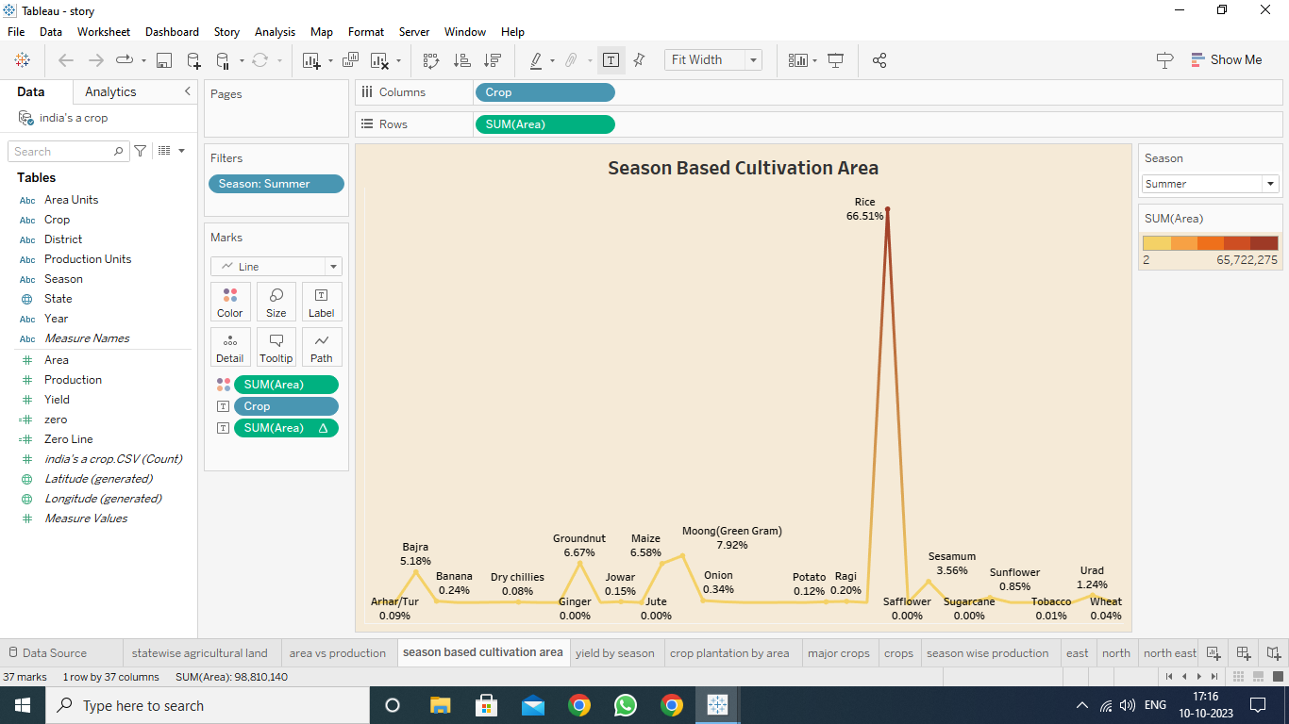

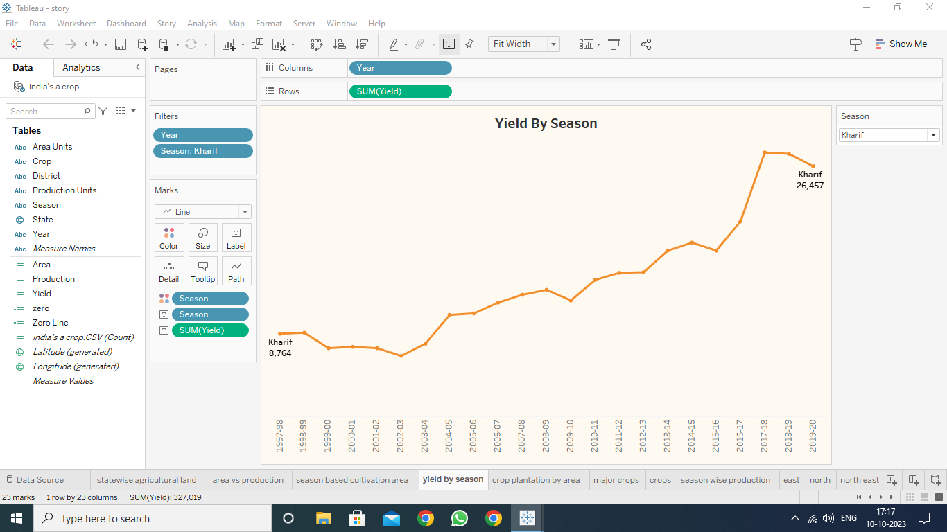

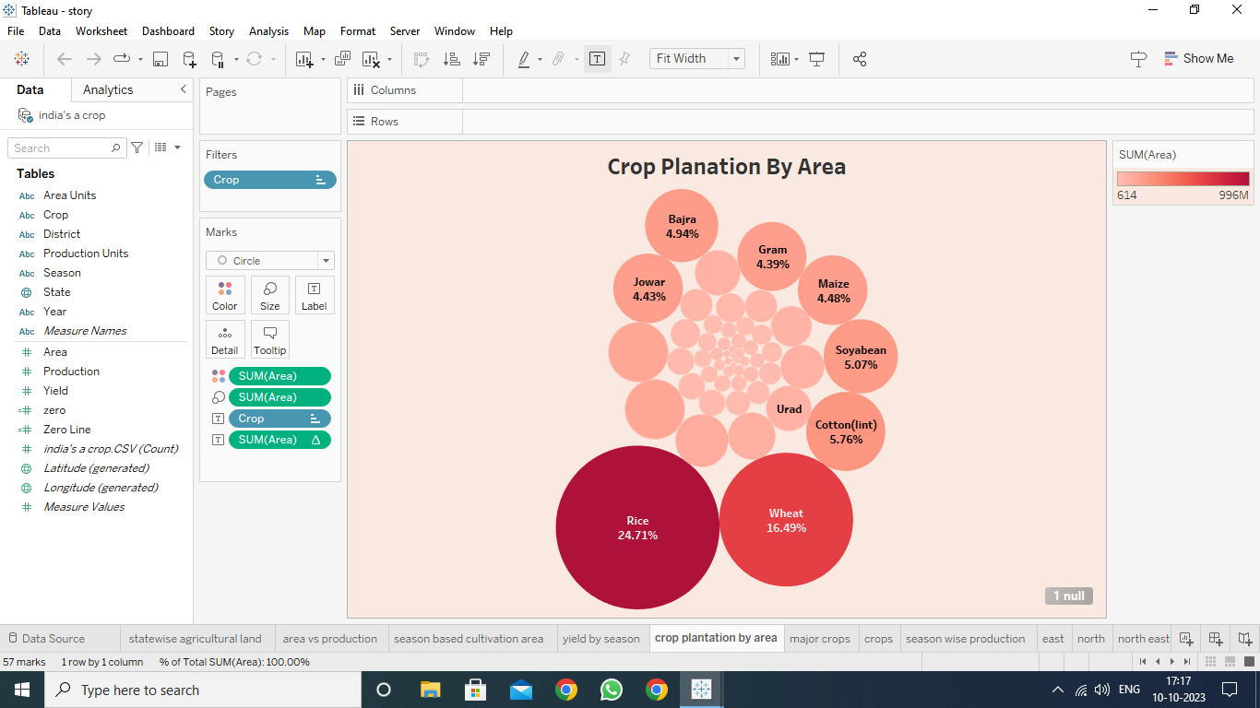

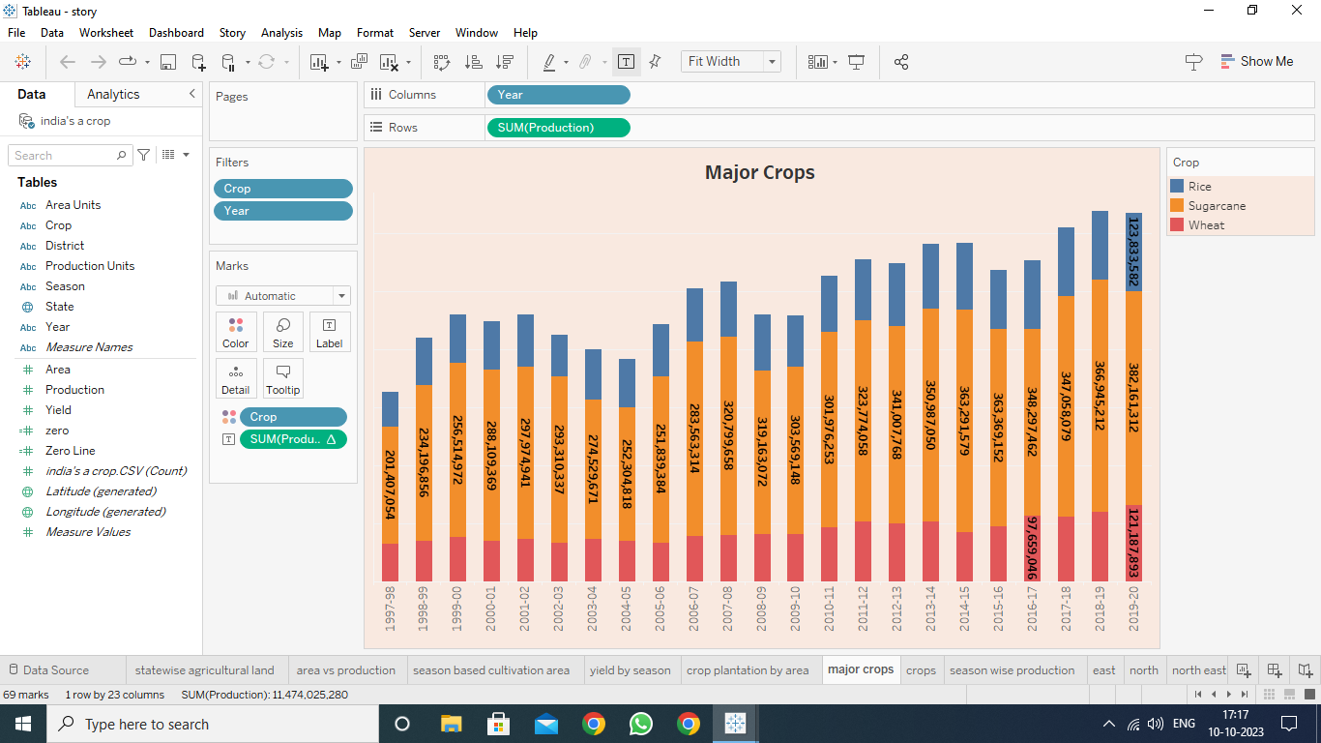

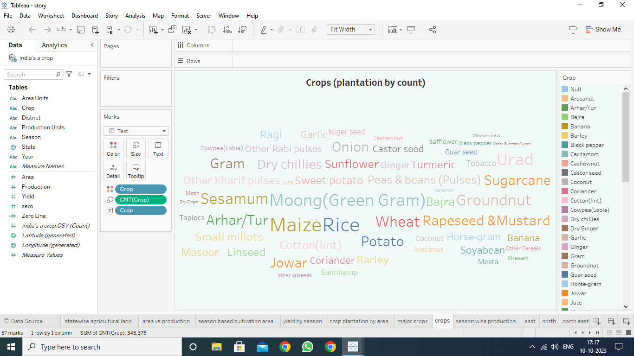

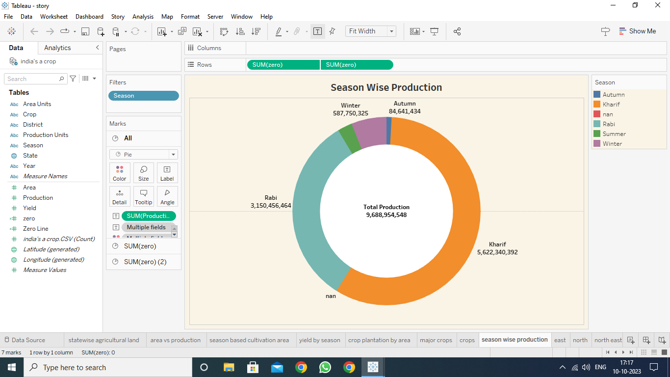

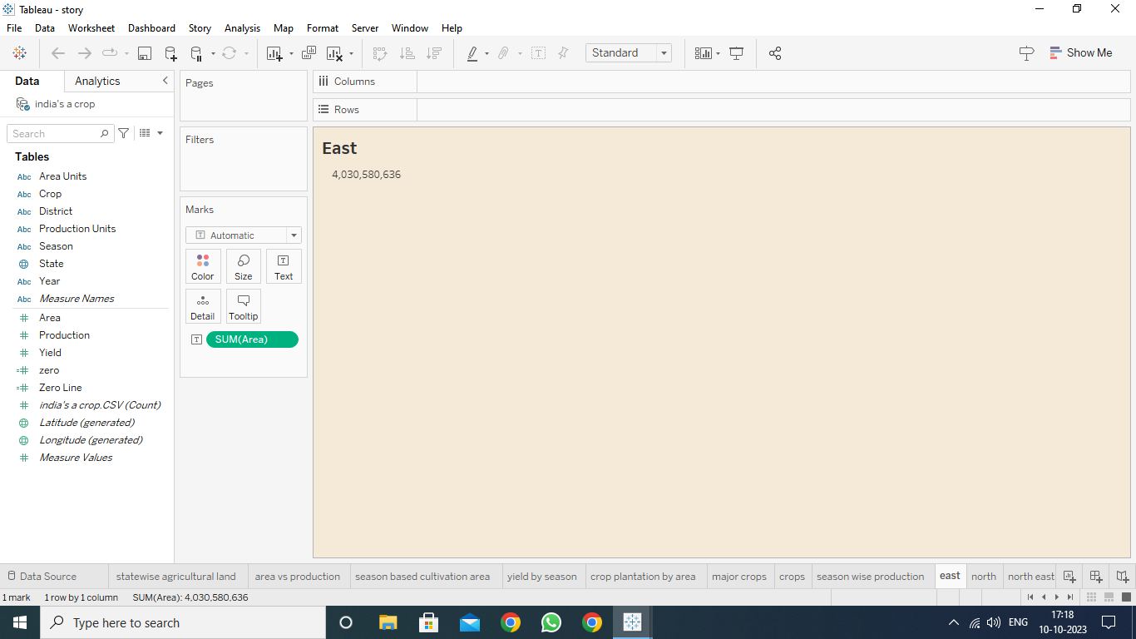

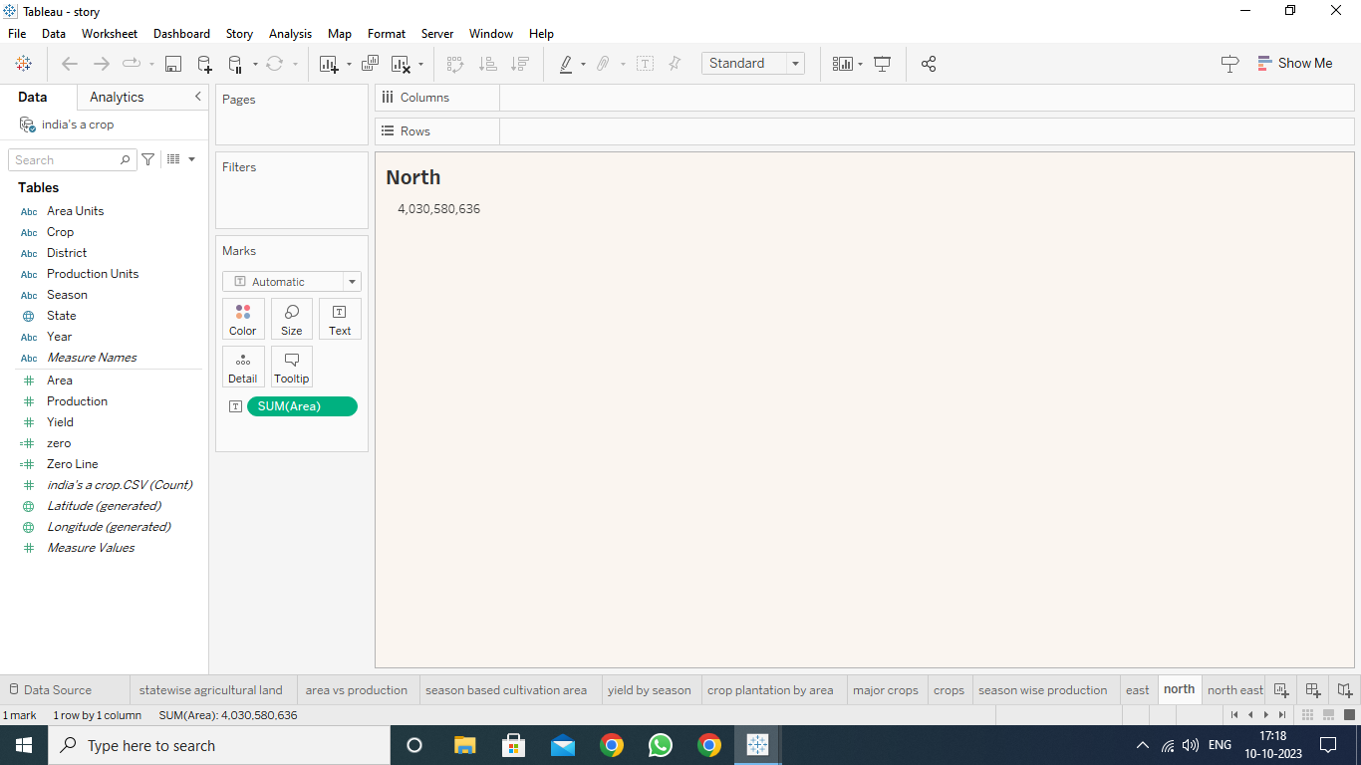

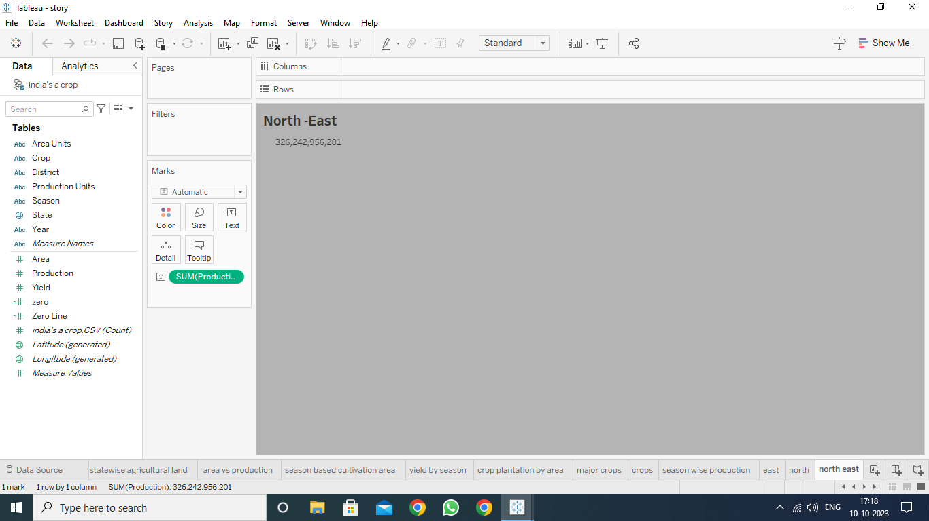

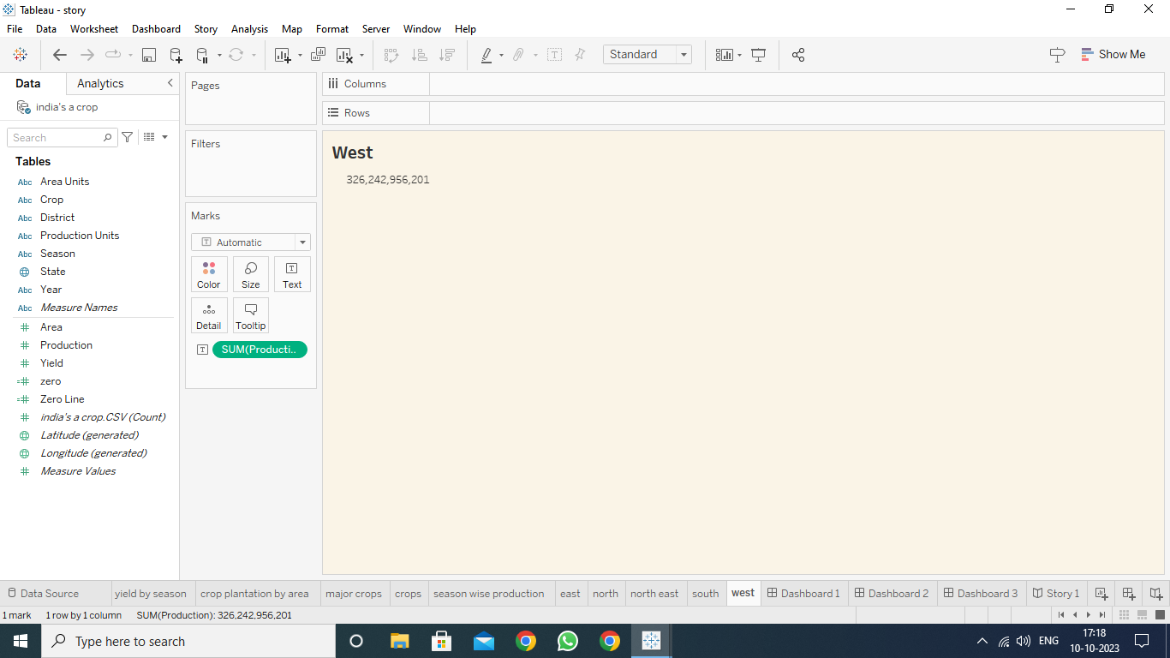

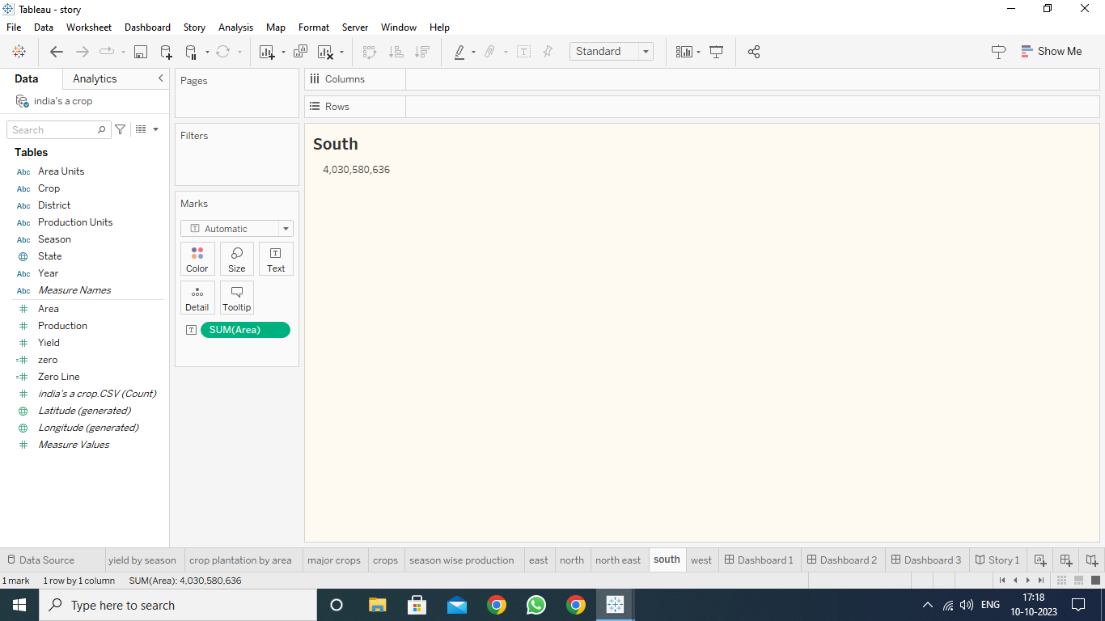

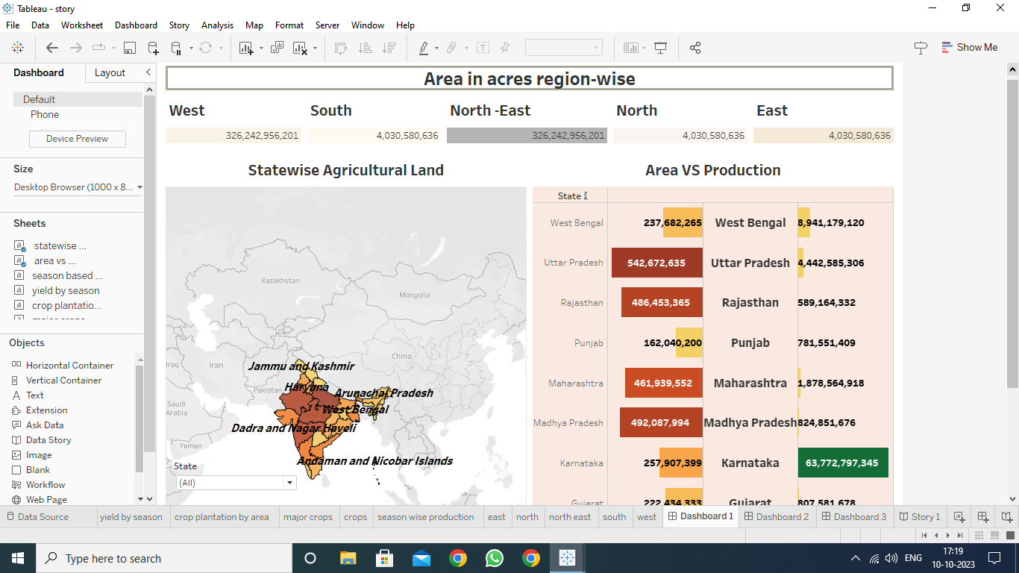

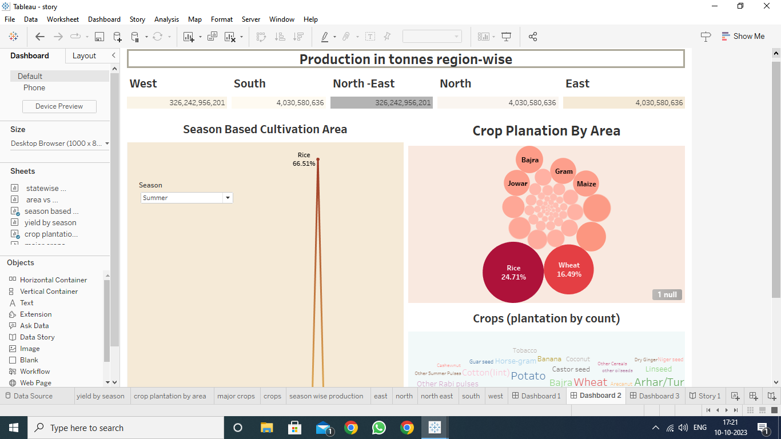

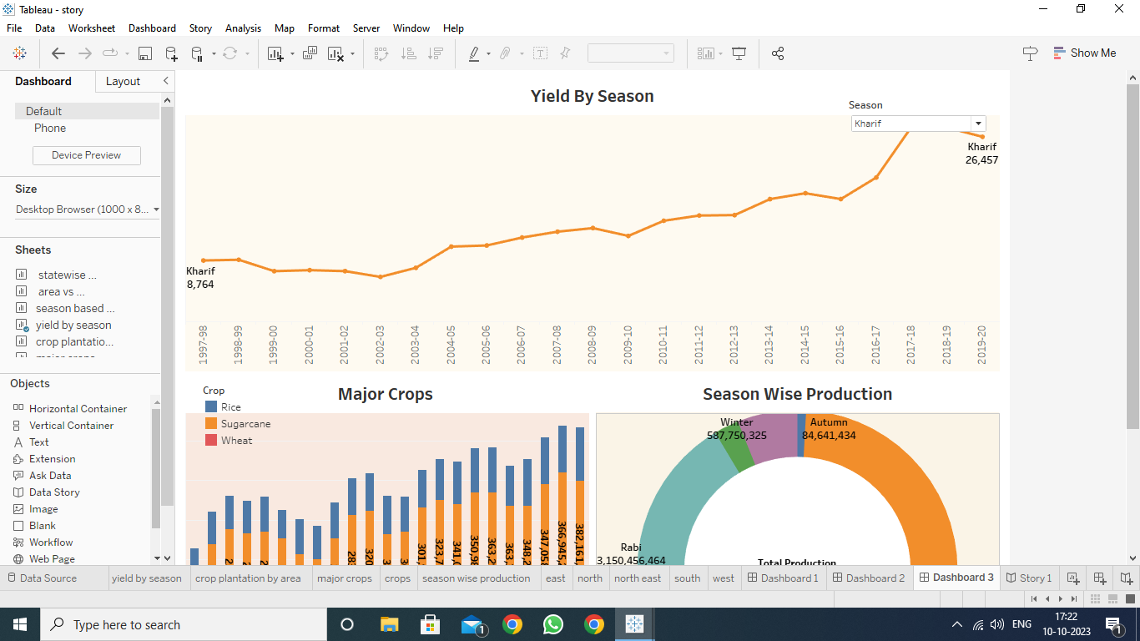

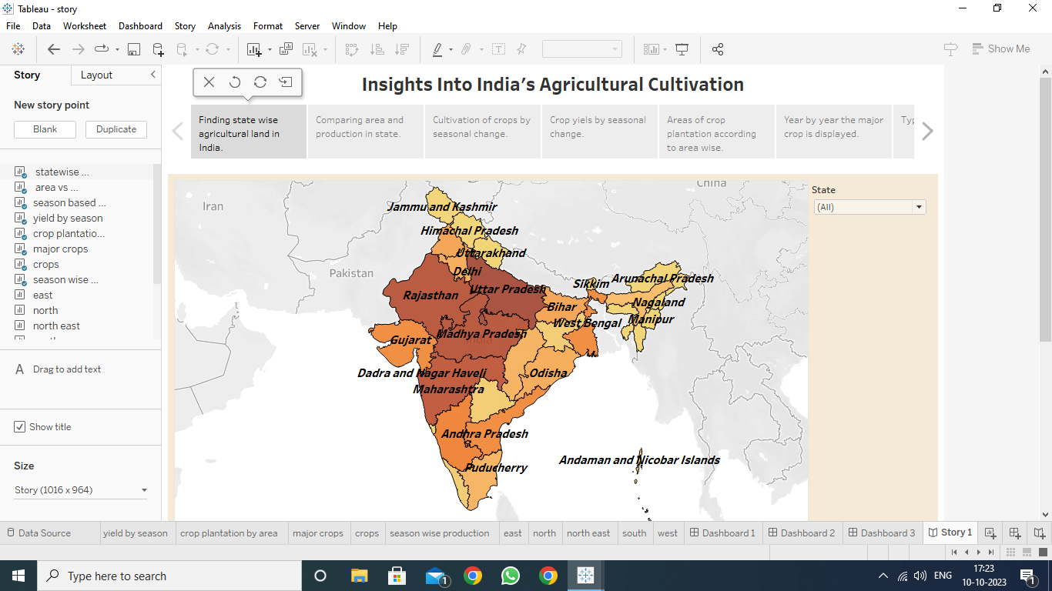

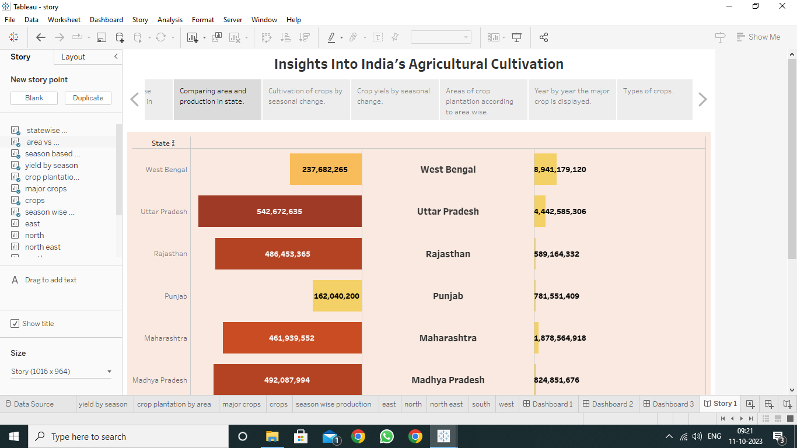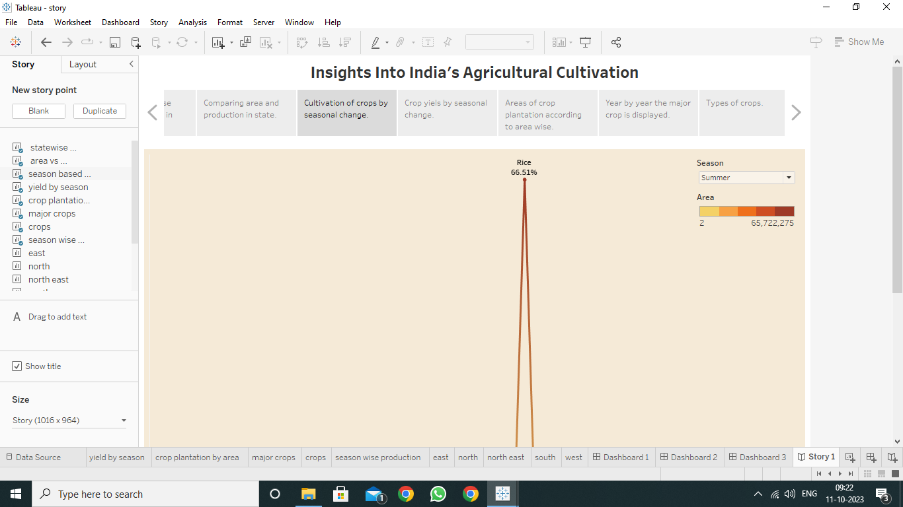

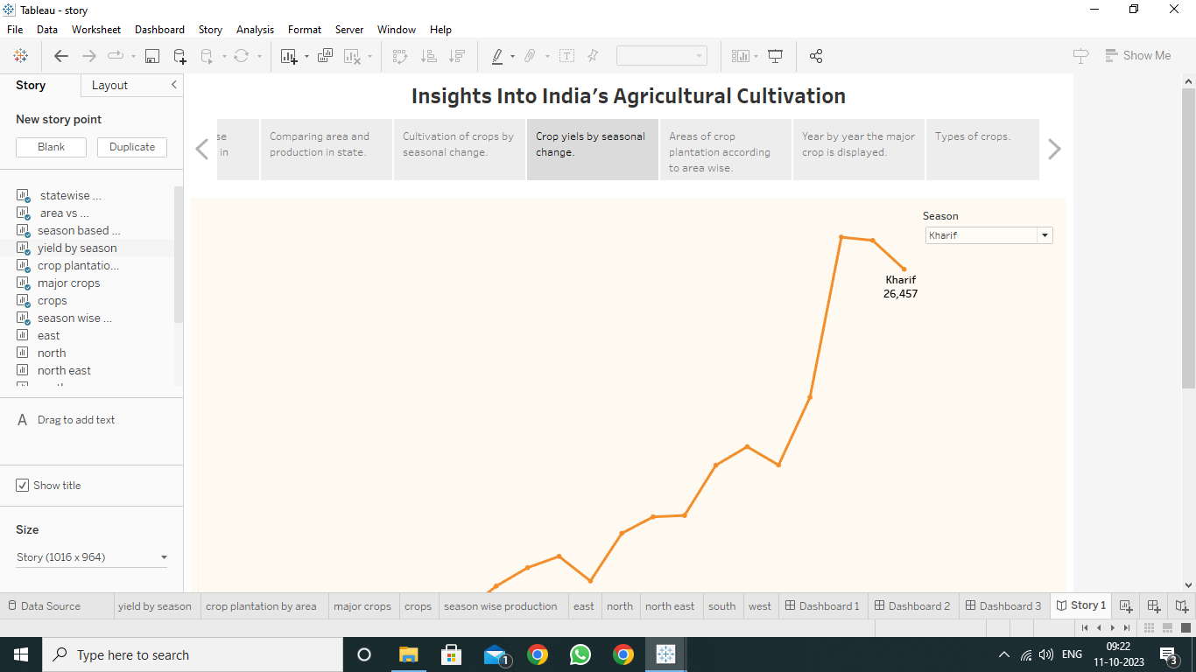

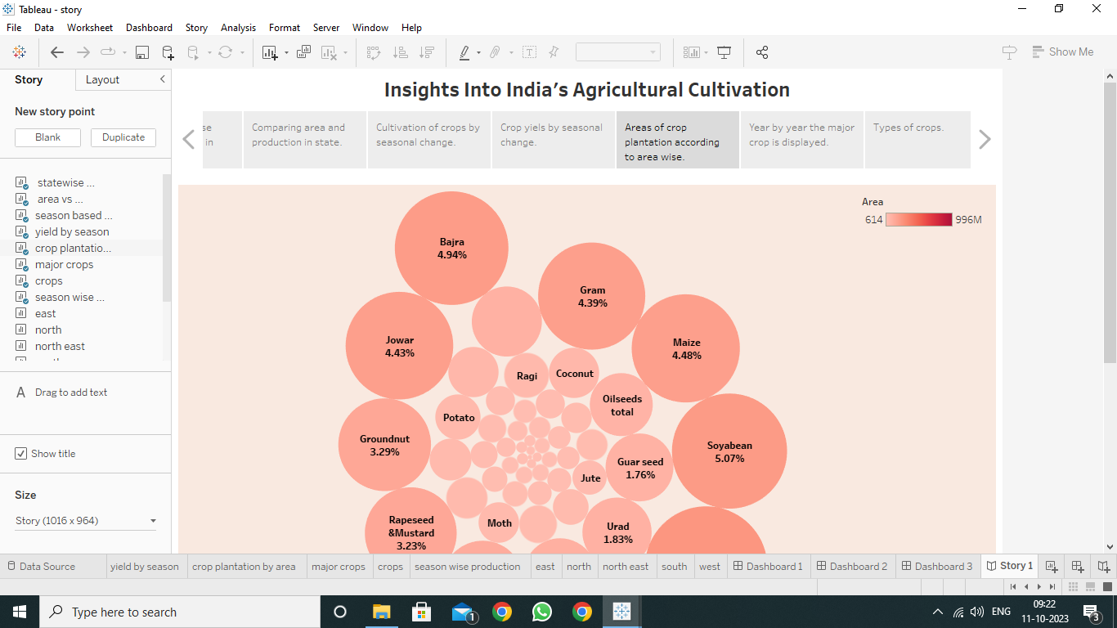

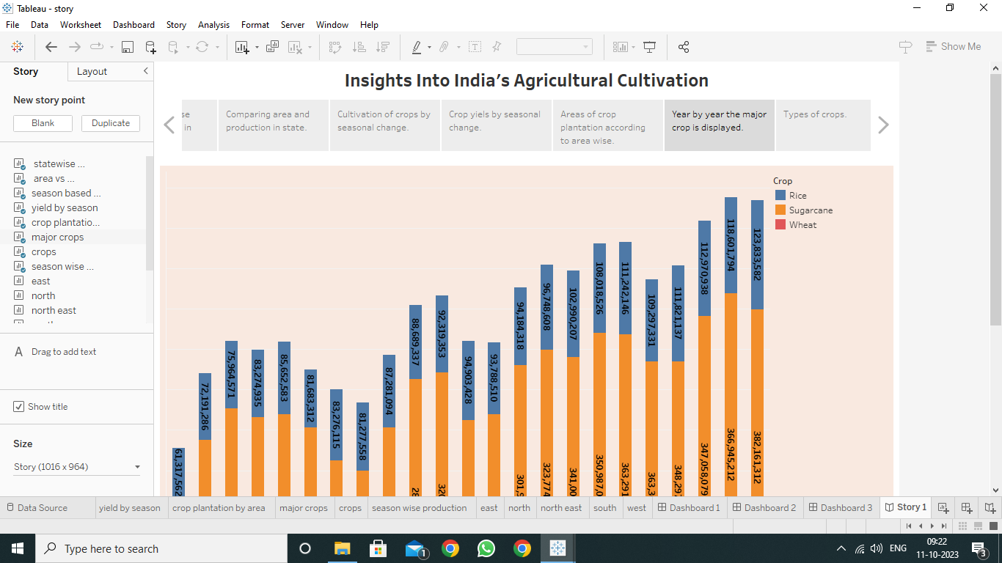

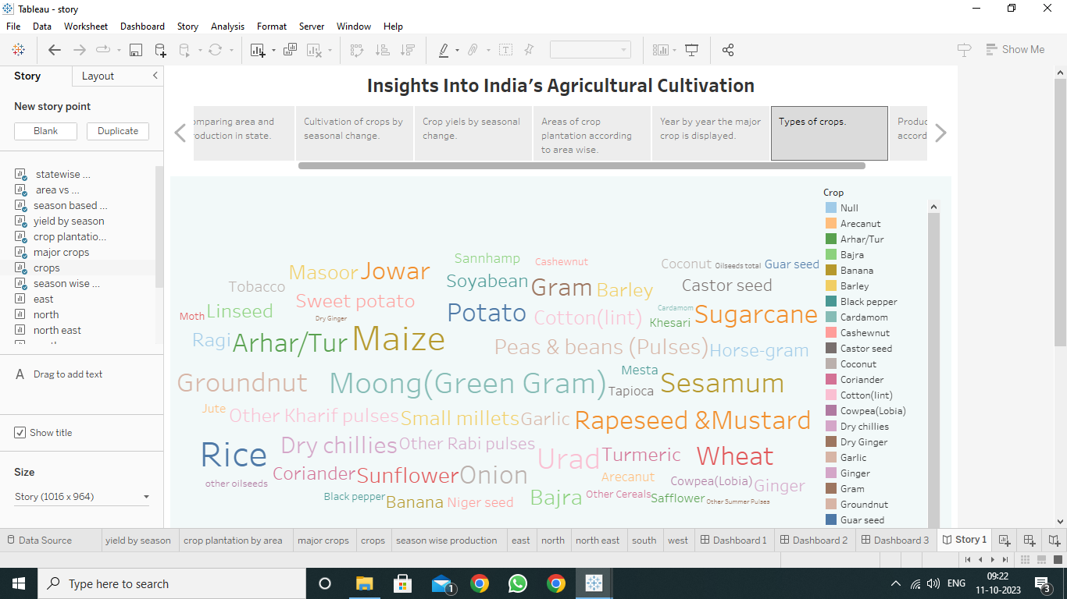

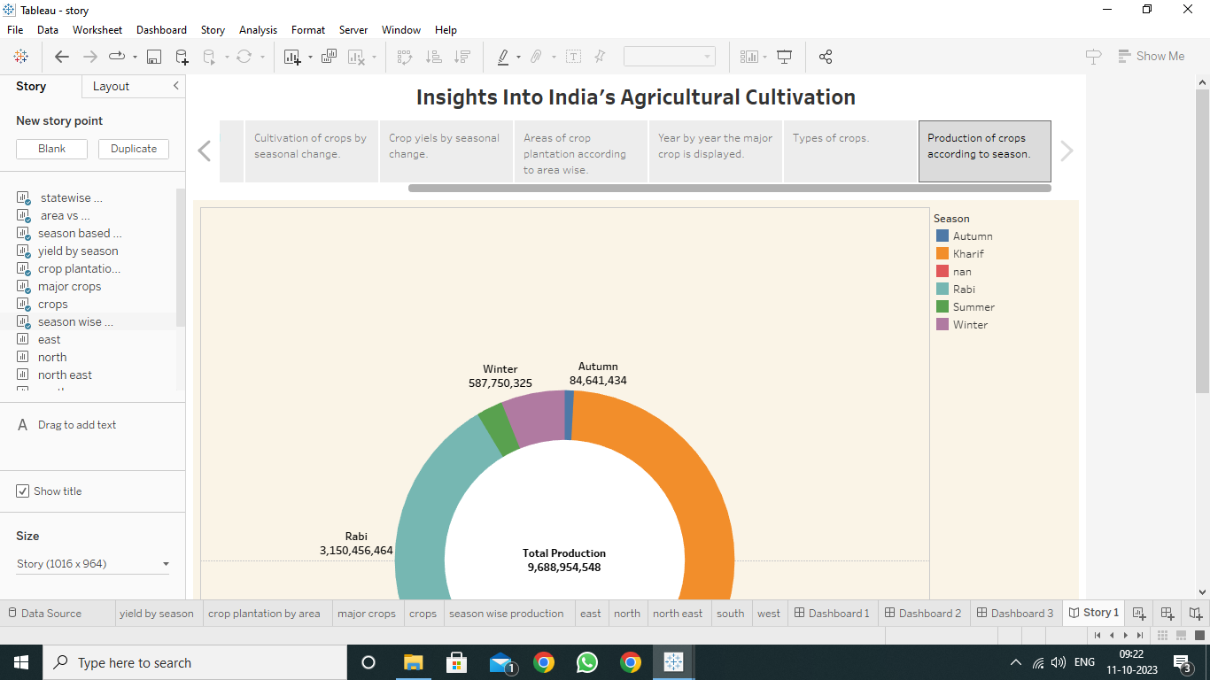

**4. Advantages and disadvantages**

**Advantages:**

* This article shows the crop quality, quantity and major crops cultivated around among different states.
* Through this data set we can easily visualize the particular crop that is cultivated in the state.
* This representation shows the full view of the major crops.

**Disadvantage:**

* The major disadvantages are the state wise crop rate is analyzed by this visualization but the area wise visualization is not available in this project.
* By use of this data set the particular period is given and pictorial representation is visualized.
* A particular data set of the crop, variable is visualized not all the variable is not in the data set.

**5. Application**

The visualization represents the period during the year (1997-2021) and full detailed about all major crops that are used. By this pictorial representation we can visualize the state wise crop, acre of agricultural field. Through this visualization all can identify the maximum and minimum crops in the state.

**6. Conclusion**

We created visualization by using different variables from the dataset. We created a graph by using variable such as area, production, season, state, yield, year, production unit, latitude, longitude and state wise crop production. It is a wide dataset of agricultural field but visualization is easy to understand.

**7. Future Scope**

There will be more of vertical and urban farming and there will also be efforts in long term to find new areas for production like barren deserts and seawater. There will be pressure on agriculture to meet future targets so innovation will be important. The future is expected to use advanced technologies and innovations to produce more food with limited land and resources increase efficiency on farms.

**8. Appendix**